**YOUR Roguelike Adventure**

**Game Design Document**

Versions:

Overview

**Introduction**

**YOUR Roguelike Adventure** is a roguelike dungeon game that has a dynamic difficulty system for the players. This is a single-player game, and the players’ goal is to get through all the levels or dungeons in the game. Between levels, there is a map building phase for the players to adjust difficulty and create their own unique game experience.

Players will attempt to get through all three areas on the map they see by choosing different monsters for different areas. Each monster will act differently in different areas on one map.

**About the Game System**

Basically, **YOUR roguelike Adventure** is using the roguelike RPG games’ system. Using generators to provide players with different area levels, including different arrangements of rooms in different levels with creeps monsters; restarting the whole game after players’ death, which is basically the same as other roguelike games.

**Basic Gameplay**

**Basic Gameplay Flow: (Will be visulized)**

Map (Choosing a monster for the first area) -- First Level (First area on the map with the chosen monster) -- Map (Choosing another monster for the second area) -- Second level (Second area on the map with the chosen monster for the second area) -- Map (Choosing the last monster for the last area) -- Last Level (Last area with the last monster)

During the gameplay, players will need to pick monsters for their future levels from a map creating phase. Different monsters will act differently in different areas. For example, in the forest level, the fire monster will be stronger if the player chose the fire monster for the forest area. (Make 1.5x damage and take 0.75x damage than normal (in the fire level or volcano level))

**Goal**

An explicit goal for the players is to get through all three levels without dying. The player-driven goal is that the player needs to arrange their difficulty by themselves by picking different monsters for different areas.

**Game Components**

**The Map**

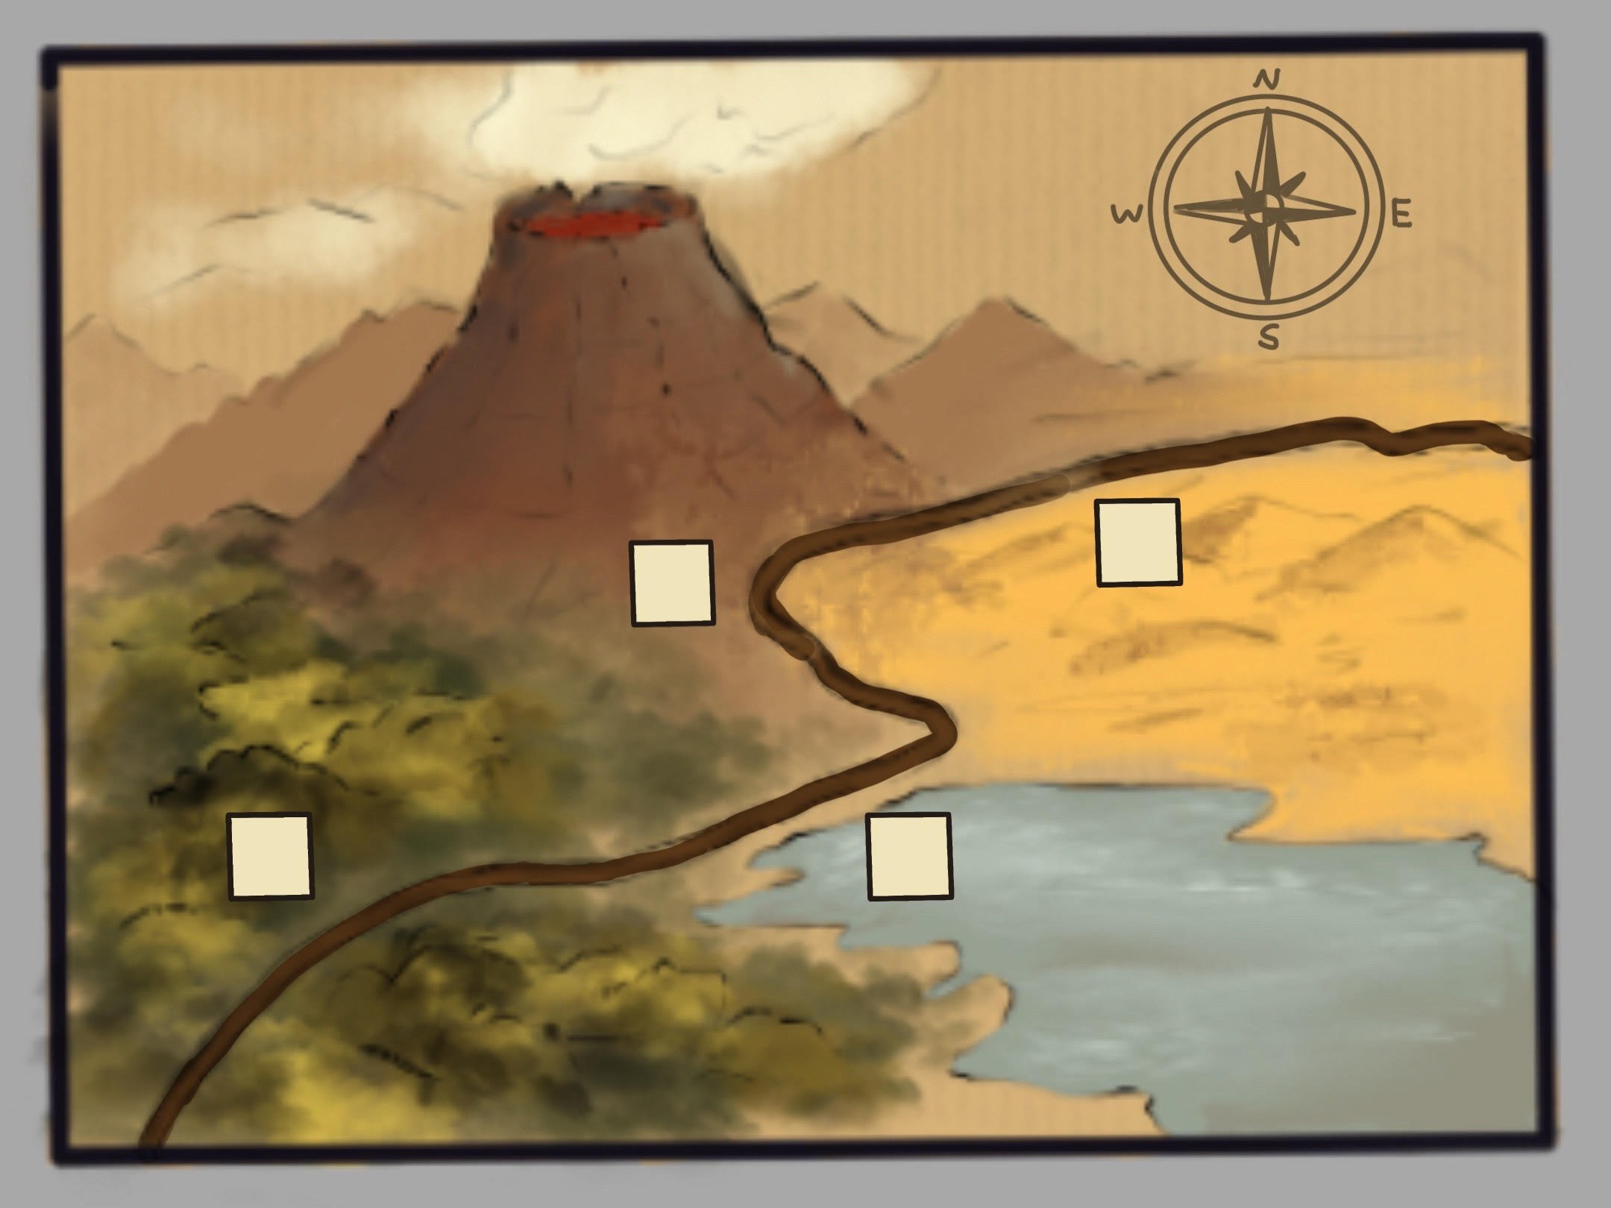

This is the map (we are currently used for early development) showed up in the map creating phase. We can see that there is a road connecting different areas. We will have three areas totally, Lake, Forest, and Volcano, represents different elements. In each area, there is a box. In this map, the first area is the forest, the second area is the lake, and the last one is the volcano. At the beginning of the game, the player needs to pick one of three monsters for the first forest level. When the player makes the choice, the player needs to get into the forest level. After the player gets through the forest level successfully, then he needs to pick another for the lake level...

**The Player (Playable Character in roguelike levels)**

Movement

Making and Taking Damage

PC Control

|  |  |
| --- | --- |
| Movements | WASD |
| Shooting | Right Key |
| Aimming | Mouse |
|  |  |
|  |  |

The player will have a total health with 100hp.

Each bullet that the player shoot will normally make 10 damage to enemies and monsters.

**Roguelike RPG Levels**

**Basic Rules:**

Each level will have five rooms connected to each other.

The order of rooms will be randomly arranged in each level.

Five rooms: 1 Boss Room with an exit, 3 small enemies rooms, 1 entrance with regeneration function (player will heal 20hp when they get into the level at first time.)

Each small enemies room will generate an array of enemies (no more than 5)

Each Boss Room will generate the monster that the player chose during the map phase for the selected level.

Generating premade rooms in different arrangements and connecting them together for each level.

Generating the enemies

Generating the monster that the player chose in the previous map creating phase

**Enemies and Monsters**

Enemies will spawn in small enemies rooms as we talked previously. Monster will spawn in monster room for each level. Based on player’s choice, different monsters will be spawn in different levels.

**Water Monster and Enemies**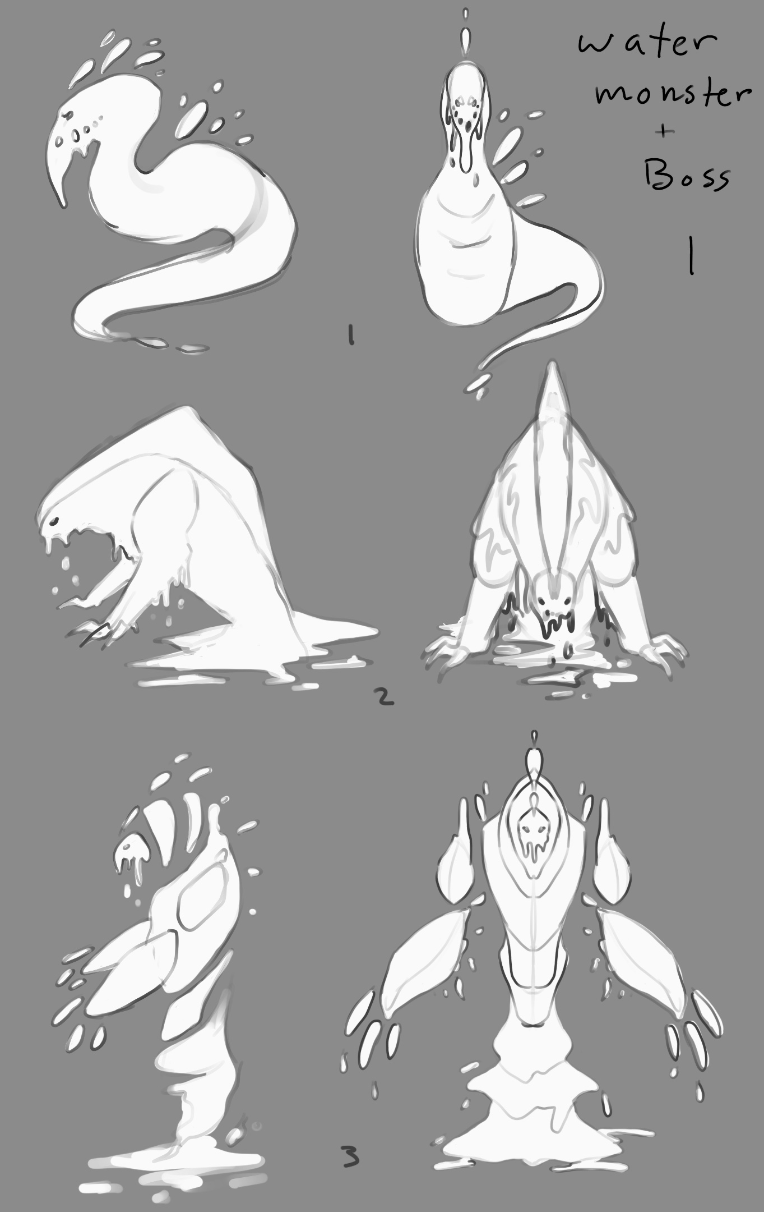

Water enemies will be spawned during water level (lake area on the map.)

Where the water monster(Boss) spawns will be selected by the player during the map phase. Water monster will be stronger in volcano area (Fire level) and weaker in forest area (Wood level).

**Market Comparison and Target Market**

YOUR Roguelike Adventure is comparable to several other roguelike games on the market.

**Similar Games:**

**Dead Cells**

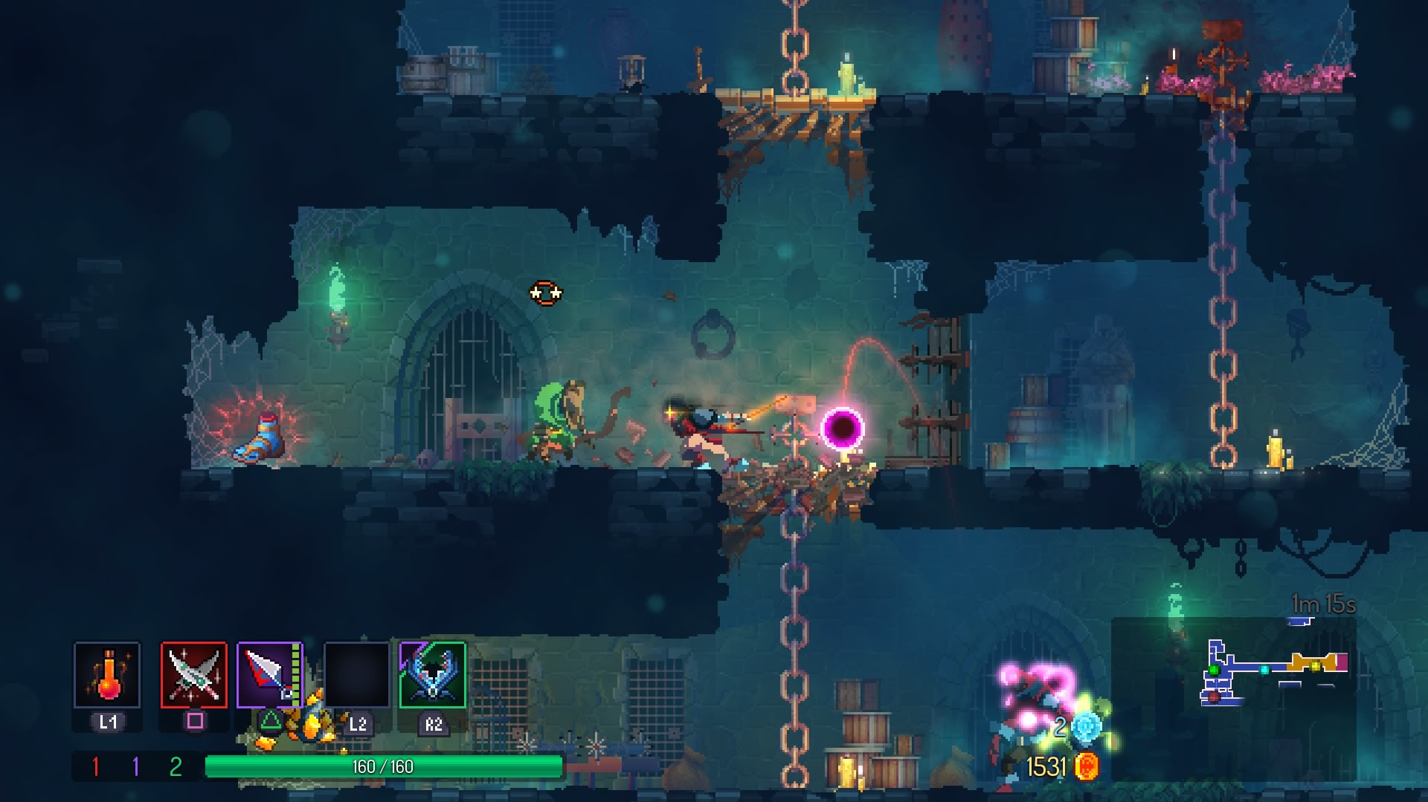

**Soul Knight:**

Similar gameplay.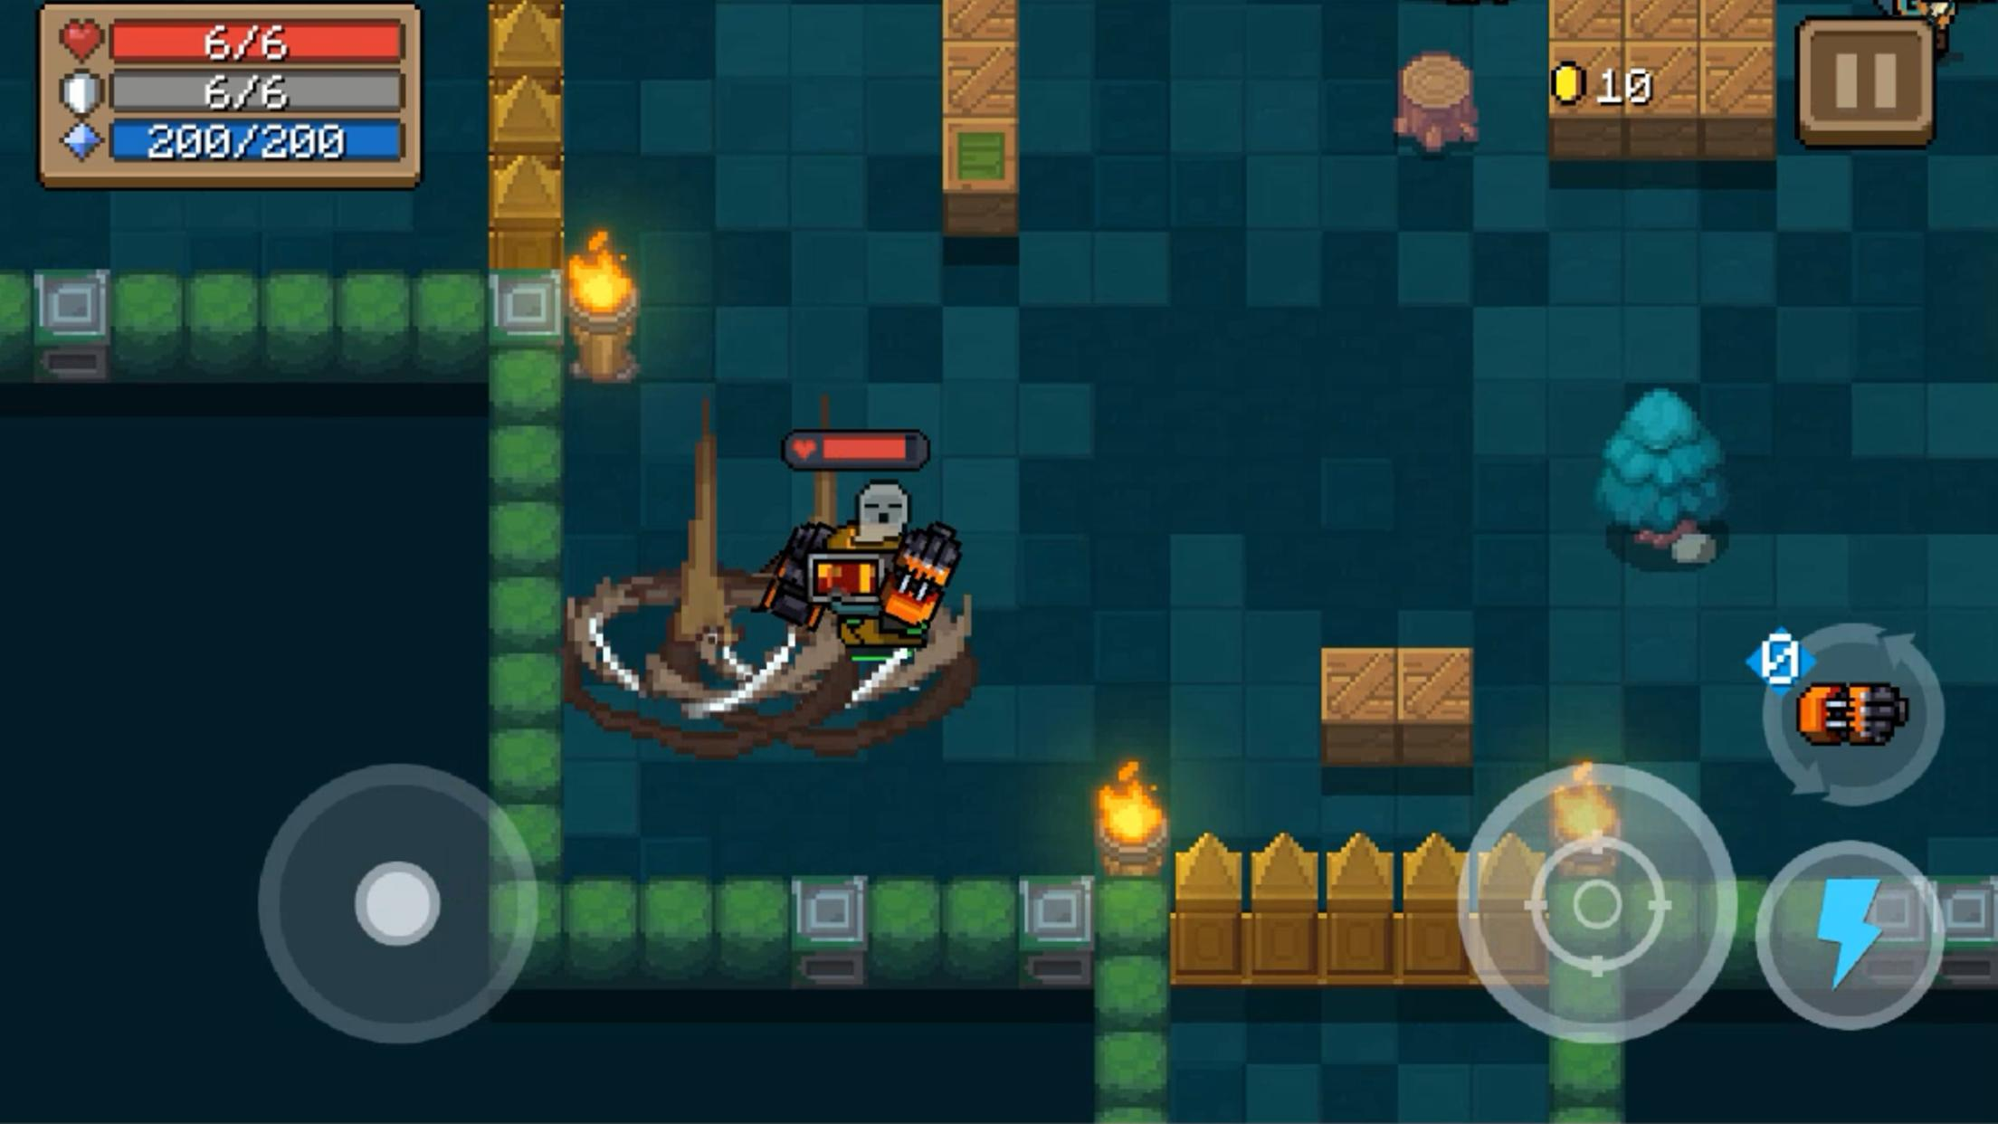

**The binding of Issac:**

Moving between rooms

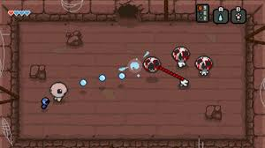

**Otherworld Legends：**

Closest game. Moving between rooms with roguelike gameplay.

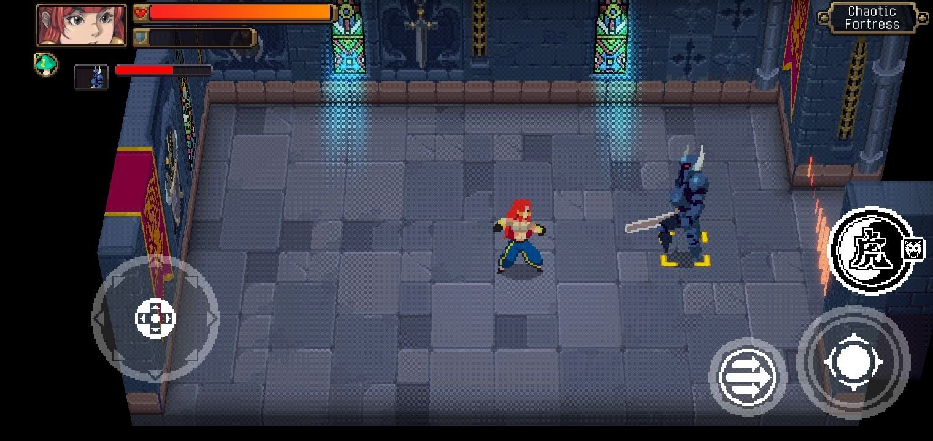

**The Unique Selling point of YOUR Roguelike Adventure:**

Compare to other similar roguelike games, YOUR Adventure is the only one that uses a dynamic difficulty system for players to build their own special gameplay.

**Target Audience**

25-40 male players who love playing roguelike games.